EventLedgerApp Test Evidences
Test 1 - submit a new event (expect 201)
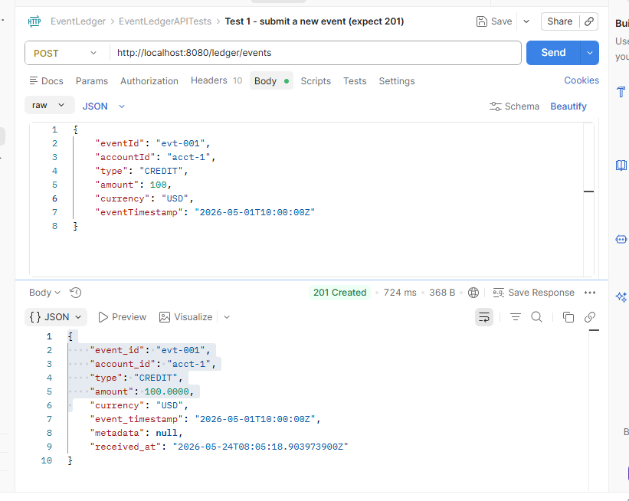
Test 2 - submit same event again (expect 200, not 201)
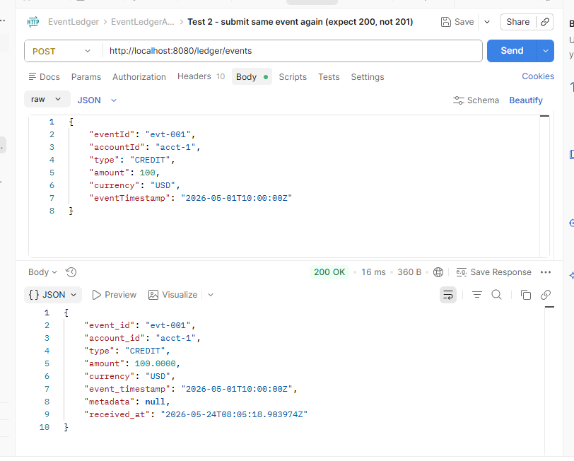
Test 3 - retrieve by ID (expect 200)
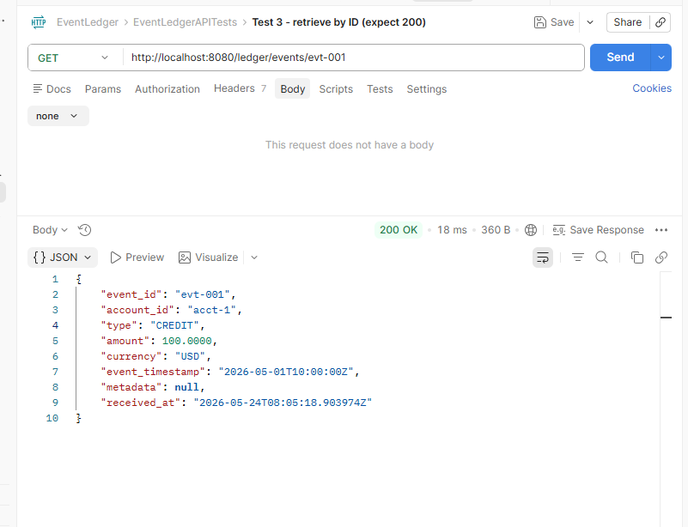
Test 4 - balance (expect 200 with balance=100)
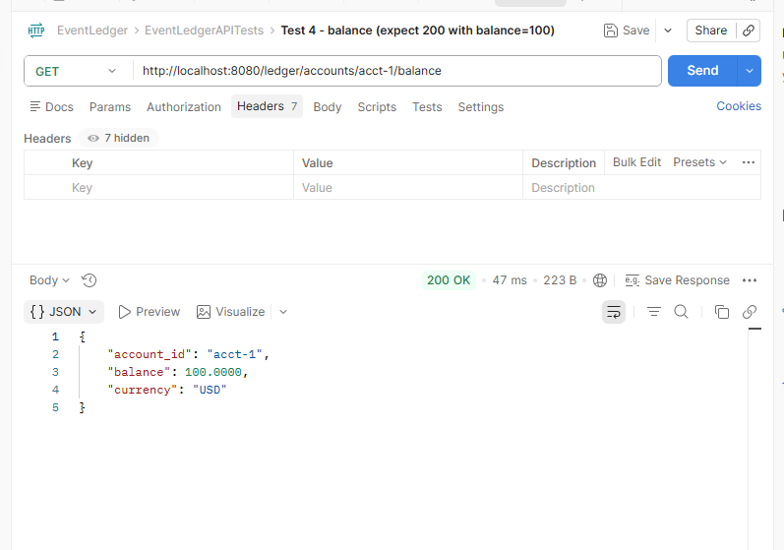
Test 5 - list events (expect array with 1 item)
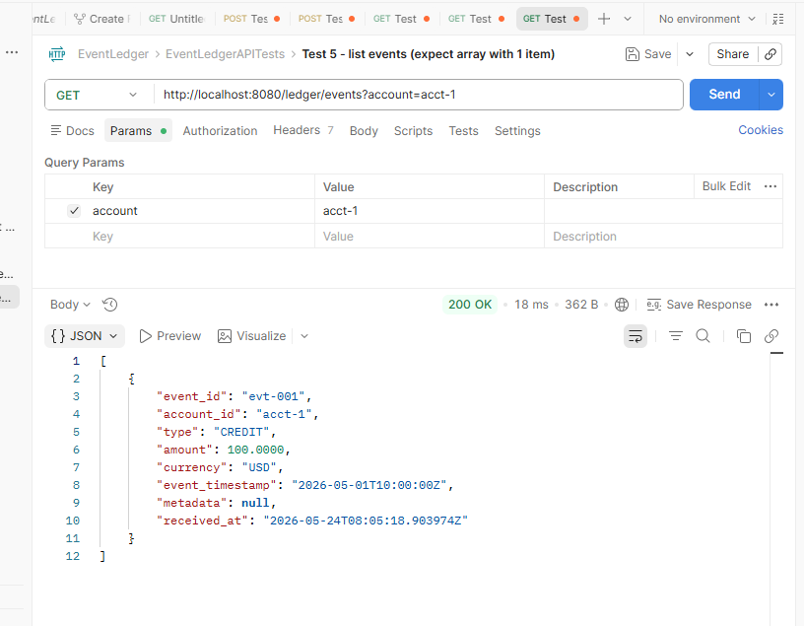

Exceptions/Errors Handling Tests
Test 1 - missing required field (expect 400 with details array)
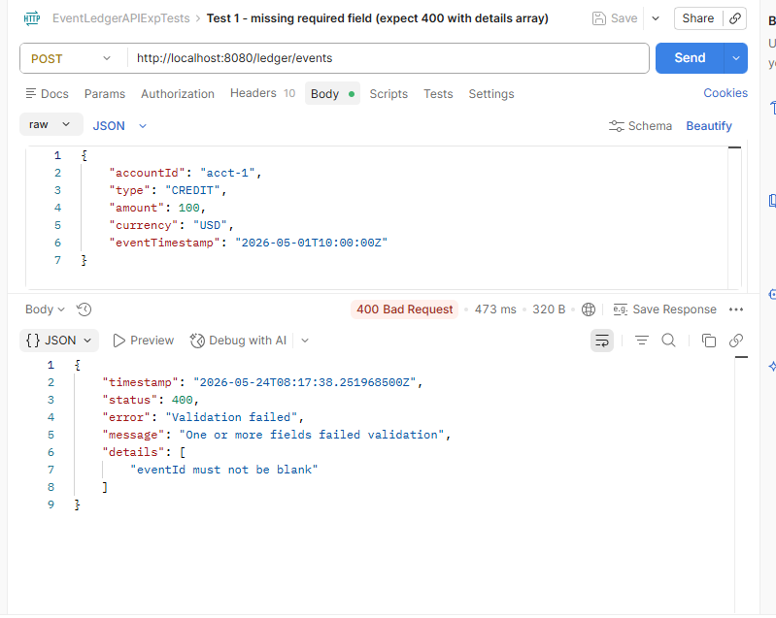
Test 2 - invalid type (expect 400 mentioning CREDIT or DEBIT)
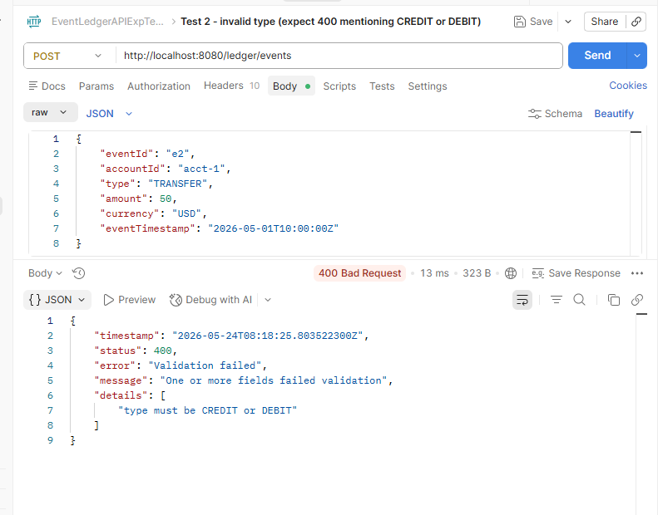
Test 3 - zero amount (expect 400)
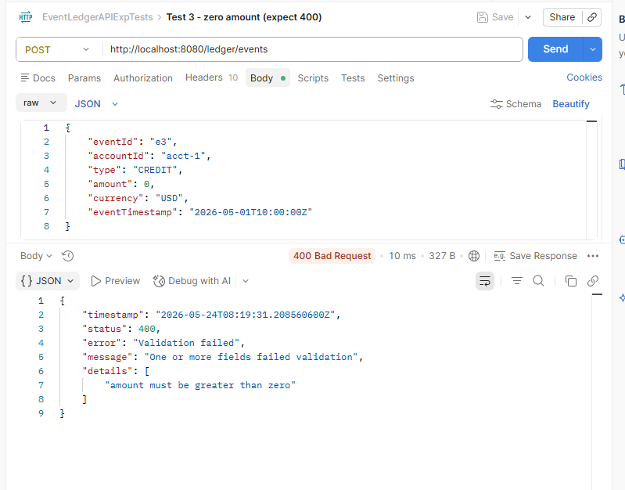
Test 4 - invalid timestamp (expect 400 mentioning ISO 8601)
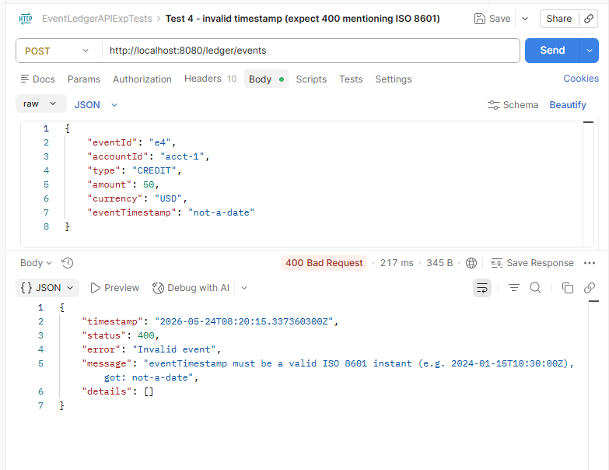
Test 5 - unknown event ID (expect 404)
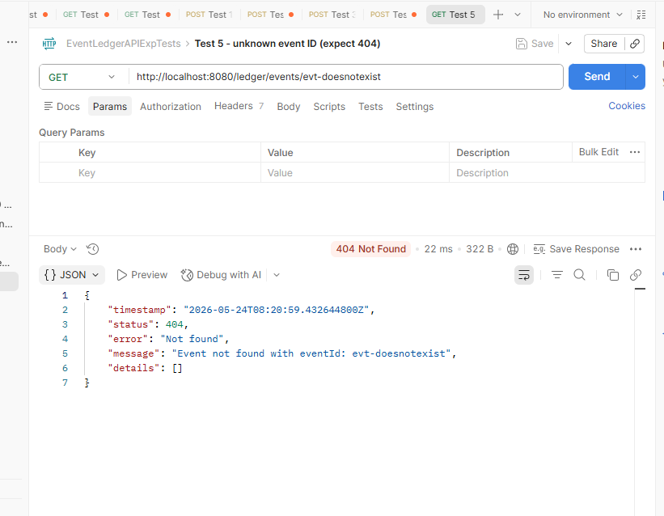

Final tests
Test -1 a. Submit 3 events out of order for acct-test
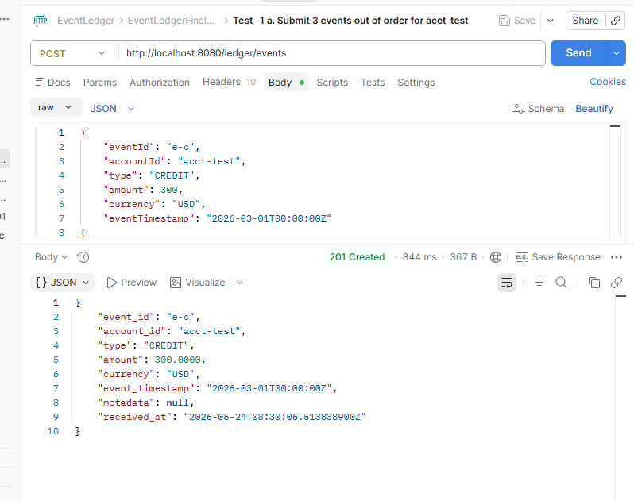
Test -1 b. Submit 3 events out of order for acct-test
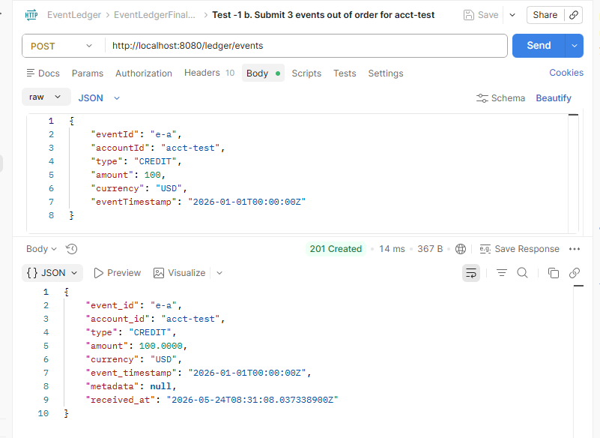
Test -1 c. Submit 3 events out of order for acct-test
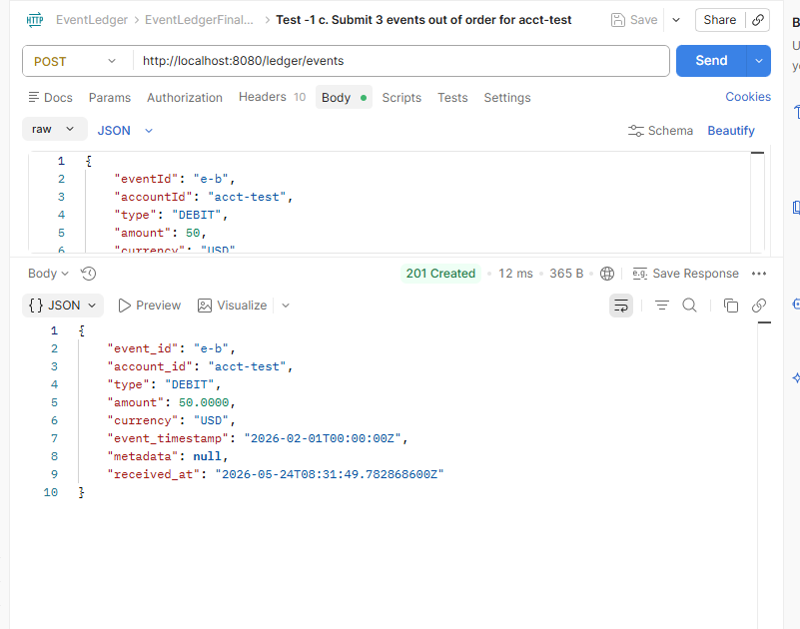

Test 2 Duplicate — must return 200 not 201
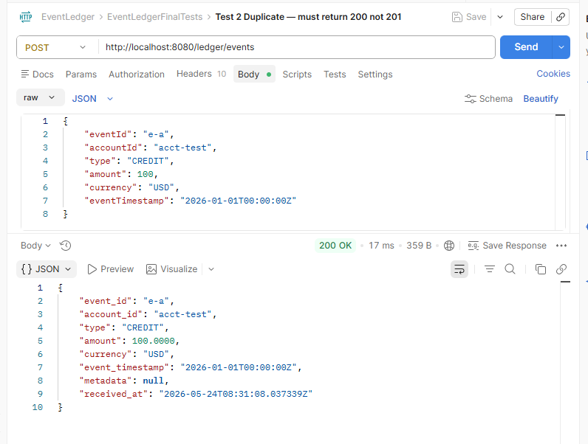
Test 3 Order check — must be e-a, e-b, e-c
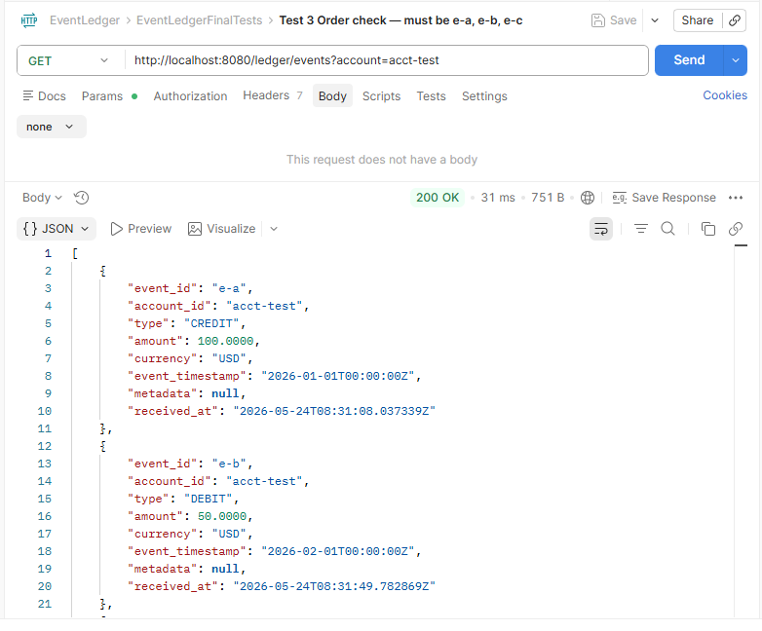
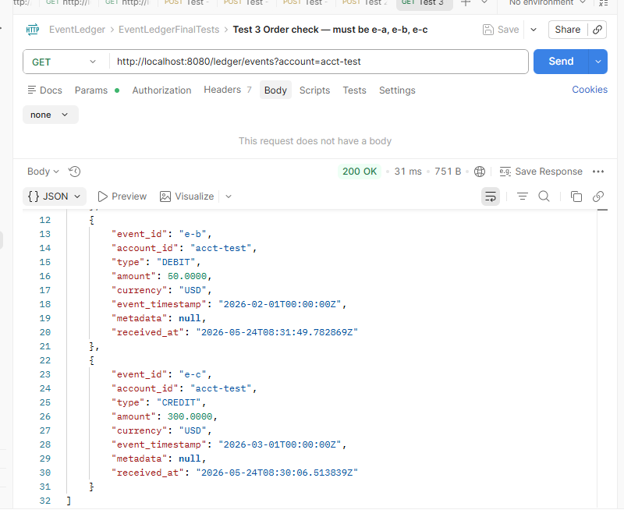
Test 4 Balance: 100 + 300 - 50 = 350
